HITEC UNIVERSITY TAXILA
Department of Computer Science
BS Computer Science Program
4st Semester, Session-2023 Section D
Lab Mid-Term Examination, Spring 2025
Subject: | CS-302L Artificial Intelligence Lab | Date: | Thursday, April 24, 2025
Marks: | 25 | Time: | 60 Minutes
Name: |  | Reg. No.:

GENERAL INSTRUCTIONS:
- Usage of Mobile phones is strictly prohibited.
- Communication of any kind is strictly prohibited.
- Transfer of data in any form is not permitted.
- Read each question carefully and follow the instructions.

Task #1 | Paper A  [CO-4 – P4] [SO – 5] | (Marks: 10)
Construct a program where:
- The user enters their favorite music genres (e.g., rock, classical, pop) into a set.
- Songs are stored in a dictionary (genre: list of songs).
- A function recommends songs from selected genres.
- A loop displays song recommendations.
- Display a warning if no songs are available for a genre.
- Create a Listener class and a derived MusicPlayer class using inheritance.

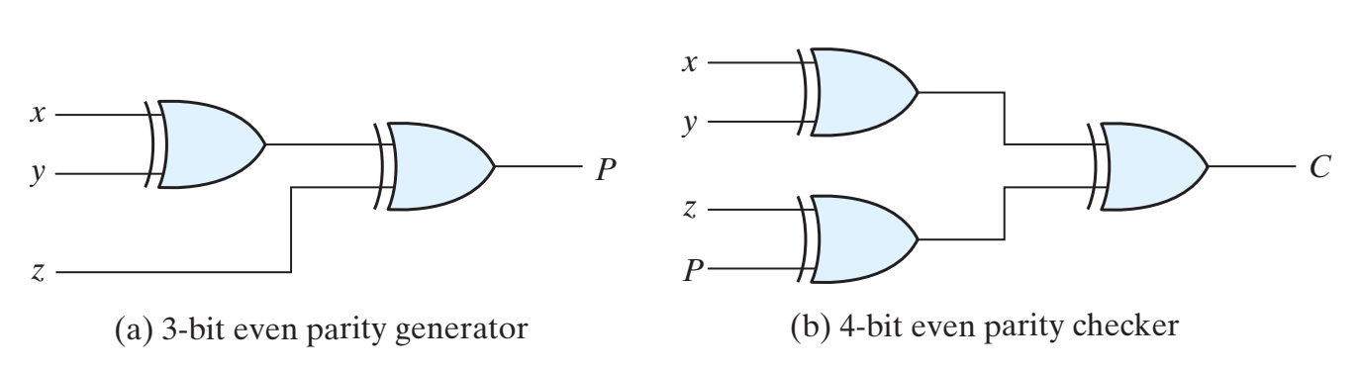
Task #2 | [CO-4 – P4] [SO – 5] | (Marks: 15)
Construct a NumPy array of shape (5, 5) filled with numbers from 1 to 25.
- Convert the data type of the array to float64.
- Reshape the array to shape (1, 25).
- Transpose the reshaped array.
- From the original 5x5 matrix, extract the following:
  - Main diagonal values
  - Upper triangle values (excluding the main diagonal)
  - Lower triangle values (excluding the main diagonal)
- Replace all the values of the original matrix with the number 7.
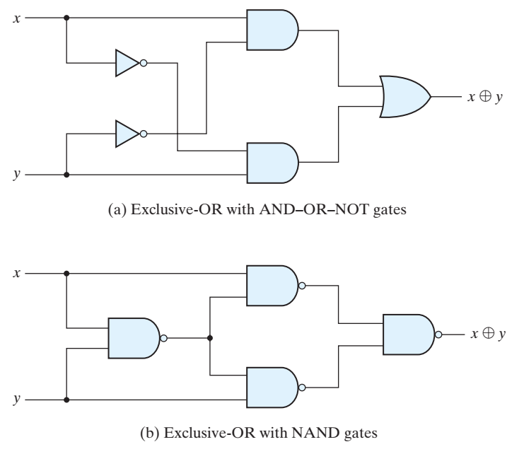

HITEC UNIVERSITY TAXILA
Department of Computer Science
BS Computer Science Program
4st Semester, Session-2023 Section D
Lab Mid-Term Examination, Spring 2025
Subject: | CS-302L Artificial Intelligence Lab | Date: | Thursday, April 24, 2025
Marks: | 25 | Time: | 60 Minutes
Name: |  | Reg. No.:

GENERAL INSTRUCTIONS:
- Usage of Mobile phones is strictly prohibited.
- Communication of any kind is strictly prohibited.
- Transfer of data in any form is not permitted.
- Read each question carefully and follow the instructions.

Task #1 | Paper B  [CO-4 – P4] [SO – 5] | (Marks: 10)
Construct a program that:
- The user enters their travel interests (e.g., beaches, mountains, historical sites) into a set.
- A dictionary stores destination options for each interest type.
- Use a function to suggest travel destinations based on user preferences.
- Use a loop to show matching places.
- Display a custom message for categories with no matches.
- Implement using a base class Traveler and a derived class DestinationAdvisor.


Task #2 | [CO-4 – P4] [SO – 5] | (Marks: 15)
Construct a Numpy array with values from 0 to 50 in steps of 5. Then:
- Extract the values at index positions 2, 4, and 6.
- Filter values greater than 30 using a Boolean mask.
- Replace values less than 15 with -1.
- Make 2 arrays, array 1 (3,2) all filled with zeroes, and array 2 (4,3) all filled with ones.
- Perform stacking like BBAA.

